CANDIDATE NAME:
CANDIDATE NUMBER:

School Of Coding
GCSE OCR (9-1) Computer Science
Component 2 - Computational Thinking, Algorithms and Programming
Practise Paper 1

Time: 1 hour 30 minutes
Instructions
- Use black ink.
- Write your name at the top of this page
- Answer all questions in the spaces provided
Information
- The marks for each question are shown in brackets
- The maximum mark for this paper is 80.

- In an adventure game the player starts with
Health, 100,
Mana, 50,
Strength, 60 and
Special Ability, None.
  - When the player reaches the Wizard at the beginning of the game
The Wizard gives the player a random Special Ability (fire,water,earth,wind).
The function randomNum(5,10) gives back a random number between 5 and 10.
Write an algorithm using the function randomNum to determine the Special Ability of the player. [3]

  - The player goes through different levels in the game and collects coins. The player cannot earn more than 1000 coins in a round. A side program has been created to help the player calculate his total coins, the least number of coins and the most number of coins, the player collected so far.
Write an algorithm that [12]
      - Asks the player how many levels he has reach so far
      - Calculate and Output the total coins so far
      - Calculate and Output the least number of coins the player collect so far
      - Calculate and Output the most number of coins the player collect so far

- The following bitmap image is using 2 colours
  - How many bits are required to store a pixel in the above image. [1]

  - Show the representation of the image above in binary. [5]

  - When storing the image, the metadata of the image needs to be stored as well.
    - What is metadata? [1]

    - Give two examples of metadata. [2]

- password = INPUT
WHILE password.LENGTH < 8 THEN
print(“The password you entered is too short”)
password = INPUT
ENDWHILE
print(“The password you entered is accepted.”)
  - State three different types of test data. [3]

  - Fill in the table below for the test case scenarios of the above algorithm. [6]
Test Data | Expected Outcome | Reason of test
password = “pass” |  | To check what happens when the password is too small.
 | The password you entered is too short

5 | 10 | 25 | 72 | 112 | 140 | 160 | 162 | 180

  - Perform a binary search in the above list to find 140. [6]

  - State a case scenario where a linear search will be preferred over binary search. [1]

- Perform an insertion sort in the following list [6]

5 | 21 | 10 | 45 | 15

- Evelyn wants to upload her audio files from the computer to her drive to store them. In order for the files to be uploaded in combount format, they need to be compressed.
  - What is compression? [2]

  - Name two types of compressions [2]

  - Which of the two types will benefit Evelyn more and why? [2]

- Computers understand binary data.
  - Convert the following numbers to binary
    - 54 [1]

    - 168 [1]

  - Convert the following binary numbers to denary
    - 0011 0100 [1]

    - 1000 1010 [1]

  - Perform a two-place left shift on the binary number 1101 0101 [1]

  - Perform a three-place right shift on the binary number 0110 1001 [1]

  - Add the binary numbers 1011 1011 and 1011 0111 [2]

  - What is the problem with the addition of the above exercise? [1]

  - How does the computer deal with that problem? [2]

- A Software Development company is doing a challenge between their programmers. For the rest of the month, half of the programmers will be programming in low-level language while the other half will be programming in high-level languages.
  - State two reasons why would the company want some programmers to use low-level languages. [2]

  - Identify and describe two translators that the programmers that are using high-level languages
can use to turn their programmes into low-level languages. [4]

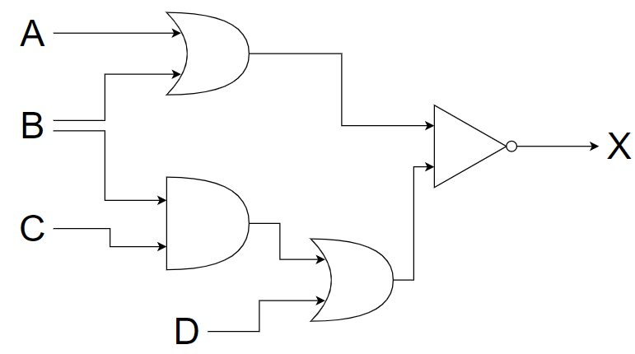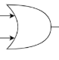
  - Write the logic expression for the circuit:
X = ___________________________________________________________________ [3]
  - Complete the truth table for the logic circuit diagram [8]

